**KALLAM HARNADHA REDDY INSTITUTE OF TECHNOLOGY**

**TO SUPPLY LEFTOVER FOOD TO POOR**

**By**

**Vipparla Nandini**

[218x1a42a9@khitguntur.ac.in](mailto:218x1a42a9@khitguntur.ac.in)

**Ponneboina Brahmaiah**

[218x1a4275@khitguntur.ac.in](mailto:218x1a4275@khitguntur.ac.in)

**Shaik Yaseen**

[228x5a4297@khitguntur.ac.in](mailto:228x5a4297@khitguntur.ac.in)

**Shaik Luqman**

[218x1a42c2@khitguntur.ac.in](mailto:218x1a42c2@khitguntur.ac.in)

**PROJECT OVERVIEW**

The "**To Supply Leftover Food To Poor**" project was conceived to address the issue of food wastage and hunger. The goal was to create a system within Salesforce that could efficiently connect sources of leftover food (restaurants, cafeterias, events) with organizations and volunteers who distribute food to those in need. This report details the project's objectives, methodology, implementation, outcomes, and future recommendations.

**INTRODUCTION**

The "**To Supply Leftover Food To Poor**" project was conceived to address the issue of food wastage and hunger. The goal was to create a system within Salesforce that could efficiently connect sources of leftover food (restaurants, cafeterias, events) with organizations and volunteers who distribute food to those in need. This report details the project's objectives, methodology, implementation, outcomes, and future recommendations.

**Objectives**

* **Reduce Food Waste**: Minimize food wastage by collecting surplus food from restaurants, hotels, events, and households.
* **Feed the Needy**: Provide nutritious and safe food to underprivileged individuals, including homeless people, low-income families, and orphanages.
* **Create a Sustainable System**: Develop a structured process for food collection, storage, and distribution to ensure efficiency and consistency.
* **Ensure Food Safety**: Implement hygiene and quality control measures to ensure the collected food is safe for consumption.
* **Promote Social Responsibility**: Encourage individuals and businesses to contribute to the cause, fostering a culture of social responsibility.
* **Build Partnerships**: Collaborate with restaurants, grocery stores, NGOs, and volunteers to expand the reach and impact of the initiative.

### 

### **Salesforce developer account creation**

### Open your browser and go to [Salesforce Developer Edition Signup](https://developer.salesforce.com/signup).

**Creating Developer Account**

* + Go to https://developer.salesforce.com/signup
  + On the sign up form, enter the following details
  + First name & Last name : VIPPARLA NANDINI TEAM
  + Email : Own email id
  + Role : Developer
  + Company : College or Company Name
  + County : India
  + Postal Code : pin code
  + Username : should be a combination of your name and company
  + 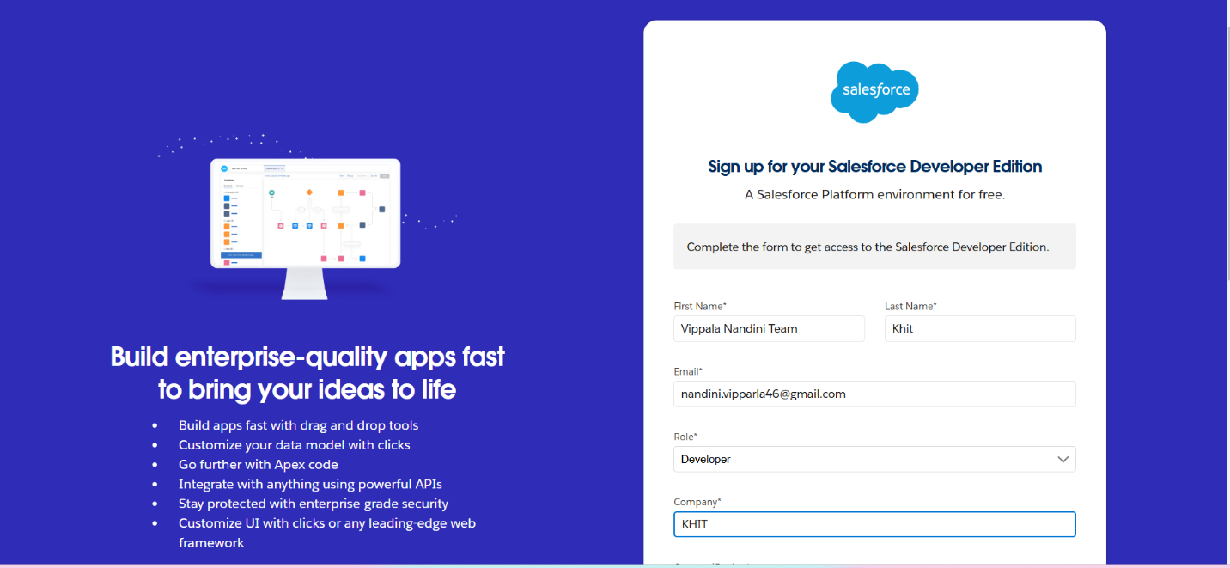

### **Account Activation**

* Go to the inbox of the email that you used while signing up
* Click on Verify Account
* Give a password and answer a security question and click on change password.

### 

* Then you will redirect to your salesforce setup page.

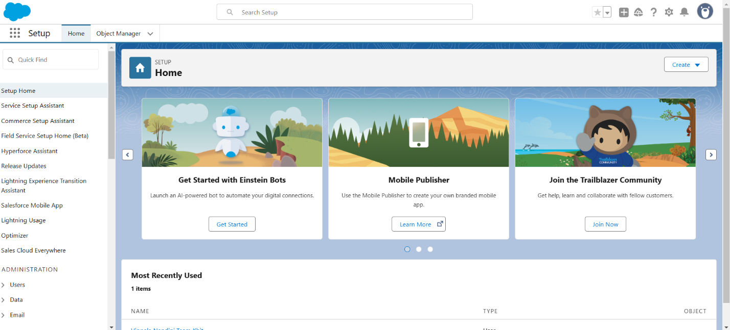

**Object**

* In salesforce, objects are used to store data
  + **Standard Objects:** Predefined by salesforce
  + **Custom Objects:** Created by users to store specific data

**Steps to create object**

* From the setup page > Click on Object Manager > Click on Create > Click on Custom Object.
* On Custom object defining page
* Enter the label name, plural label name, click on Allow reports, Allow search.
* Click on Save
* 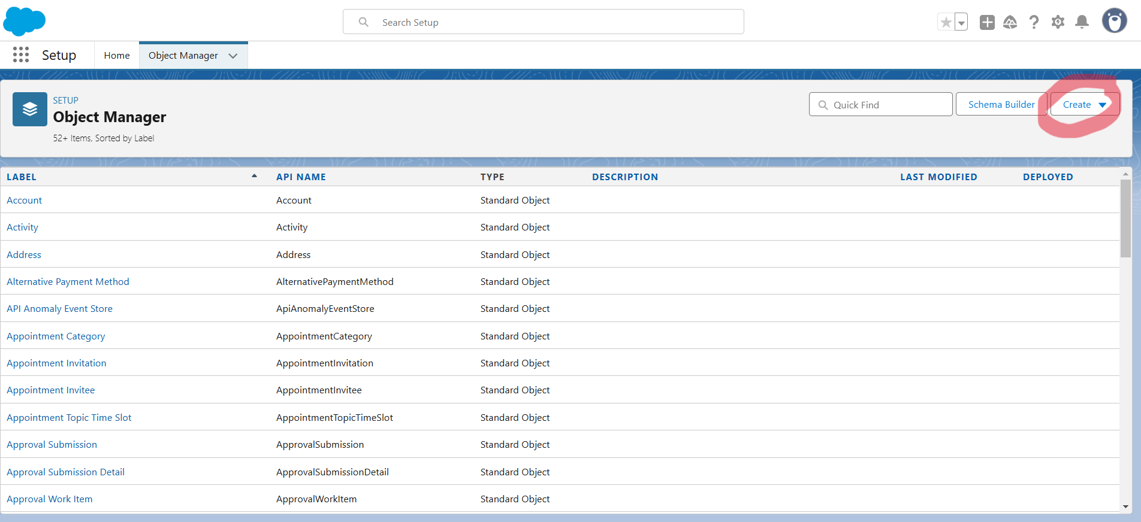
* **Venue object**
* To create an object:
* From the setup page > Click on Object Manager >Click on Create >Click on Custom Object.
* Enter the label name >Venue
* Plural label name >Venues
* Enter Record Name Label and Format
* Record Name >Venue Name
* Data Type >Text
* Click on Allow reports and Track Field History, Allow Activities.
* Allow search >Save.

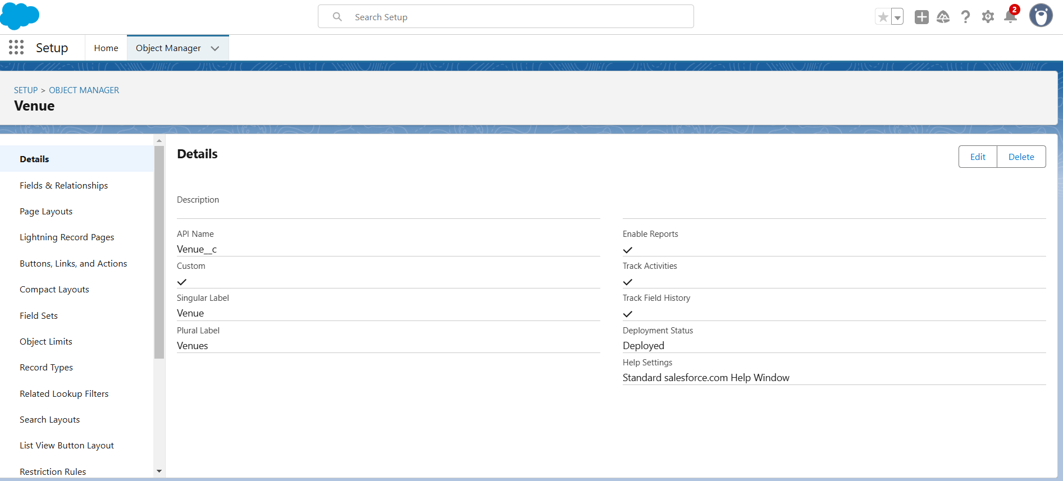

* **Drop-off point object**
* To create an object:
* From the setup page>Click on Object Manager>Click on Create>Click on Custom Object.
* Enter the label name>Drop-Off Point
* Plural label name>Drop-Off Points
* Enter Record Name Label and Format
* Record Name>Drop-Off point Name
* Data Type>Text
* Click on Allow reports and Track Field History, Allow Activities
* Allow search>Save.

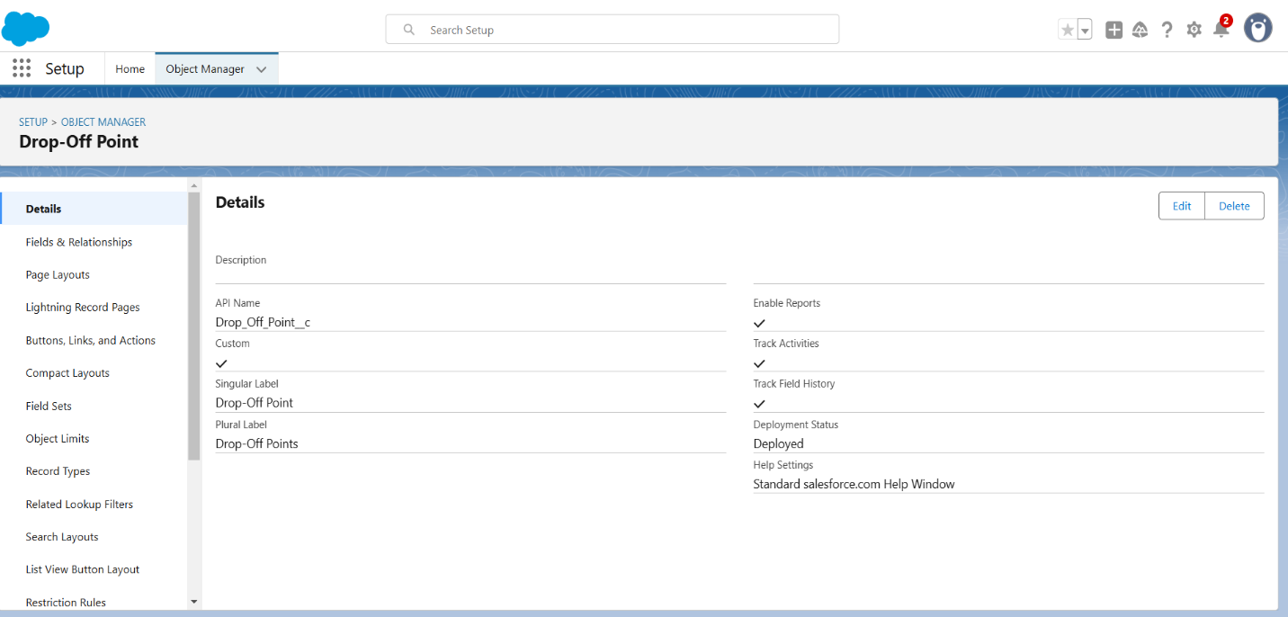

* **Task Object**
* To create an object:
* From the setup page>Click on Object Manager>Click on Create>Click on Custom Object.
* Enter the label nam>Task
* Plural label name>Tasks
* Enter Record Name Label and Format
* Record Name>Task Name
* Data Type>Text
* Click on Allow reports and Track Field History, Allow Activities
* Allow search>Save.

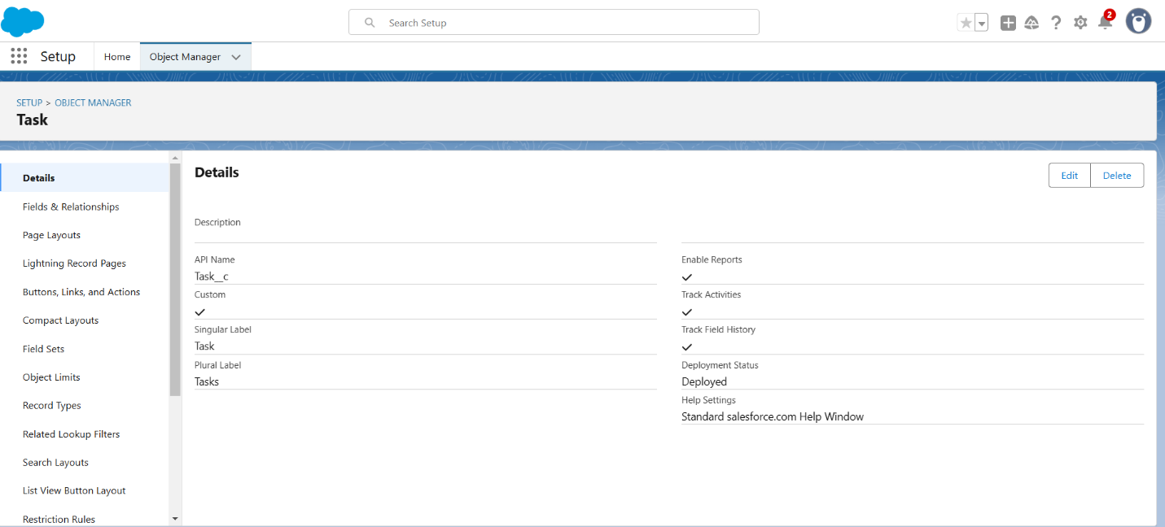

* **Volunteer Object**
* To create an object:
* From the setup page>Click on Object Manager>Click on Create>Click on Custom Object.
* Enter the label name>Volunteer
* Plural label name>Volunteers
* Enter Record Name Label and Format
* Record Name>Volunteer Name
* Data Type>Text
* Click on Allow reports and Track Field History, Allow Activities
* Allow search>Save**.**

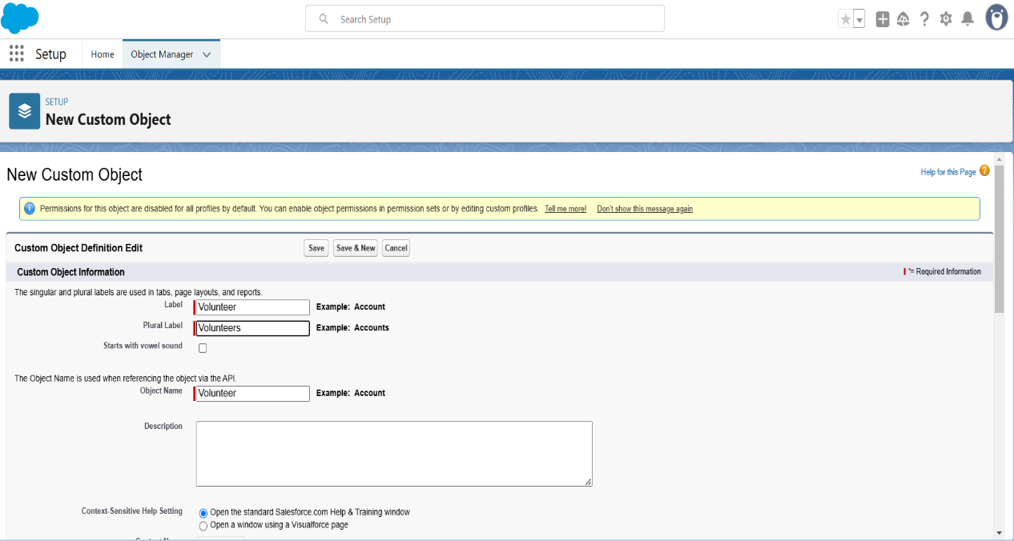

* **Execution Details Object**
* To create an object:
* From the setup page>Click on Object Manager>Click on Create>Click on Custom Object.
* Enter the label name>Execution Detail
* Plural label name>Execution Details
* Enter Record Name Label and Format
* Record Name>Execution Detail Name
* Data Type>Text
* Click on Allow reports and Track Field History, Allow Activities
* Allow search>Save.

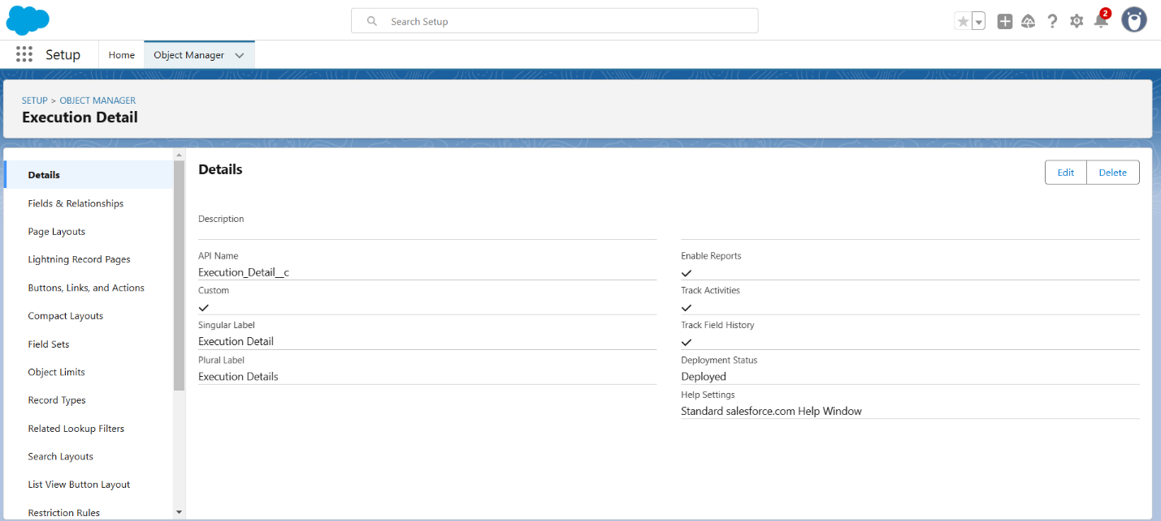

**Tabs**

* A tab is like a user interface that is used to build records for objects and to view the records in the objects.

### **Creating a Custom Tab**

* To create a Tab:(Venue)
* Go to setup page>type Tabs in Quick Find bar>click on tabs>New (under custom object tab)
* Select Object(Venue)>Select the tab style>Next (Add to profiles page) keep it as default>Next (Add to Custom App)  uncheck the include tab .
* Make sure that the Append tab to users' existing personal customizations is checked.
* Click save.

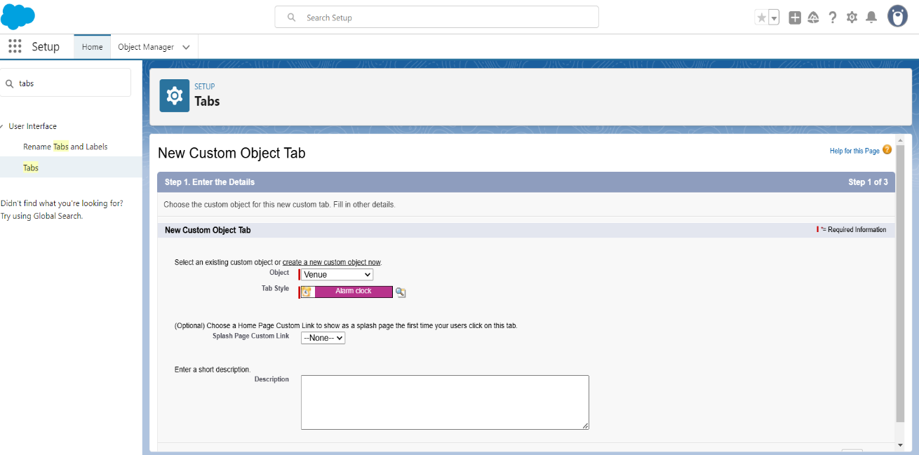

* **Creating Remaining Tabs**
* Now create the Tabs for the remaining Objects, they are “Drop-Off -Point, Task, Volunteer, Execution Details”.
* Follow the same steps as mentioned in the above.

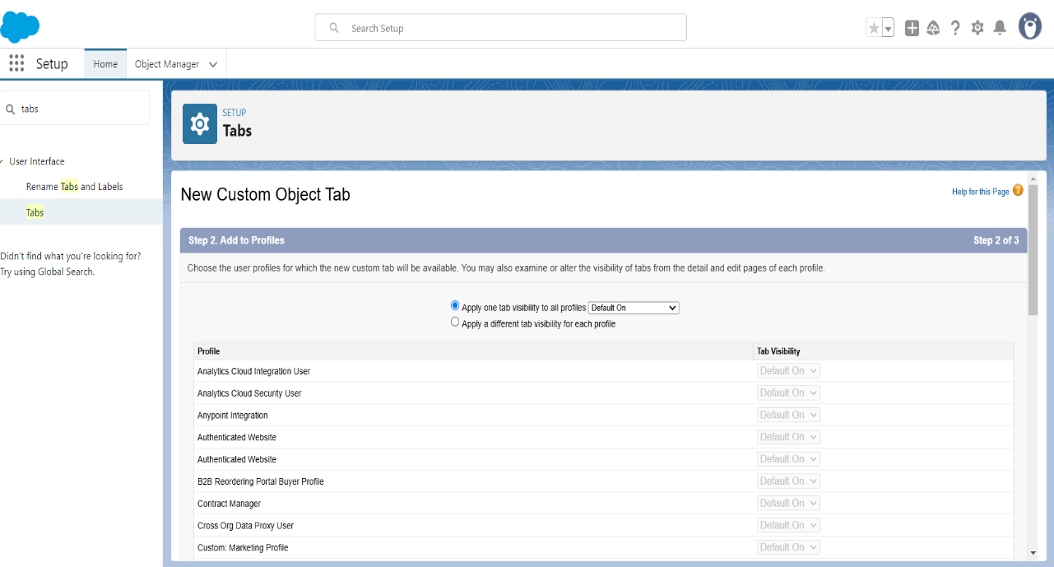

* Tabs Created.

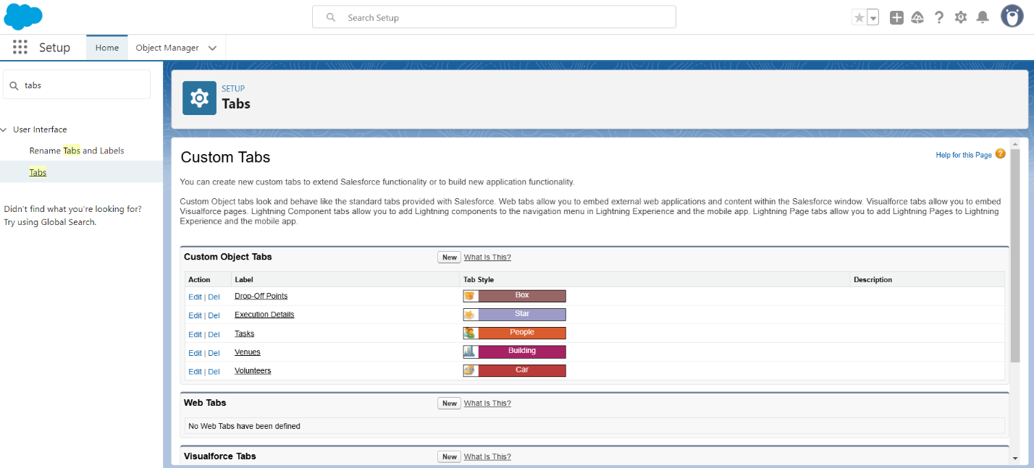

### **The Lightning App**

* A Lightning app in Salesforce is a custom page or app that can be used to create, update, and access records in Salesforce.

### **Create a Lightning App**

* To create a lightning app page:
* Go to setup page>search “app manager” in quick find>select it>click on New lightning App.
* Fill the app name in app details and branding as follow>App Name : FoodConnect, Developer Name : This will auto populated, Image : optional, Primary color hex value : keep this default.
* Then click Next >Set Navigation Style as Standard Navigation>Next.
* Utility Items keep it as default>Next.

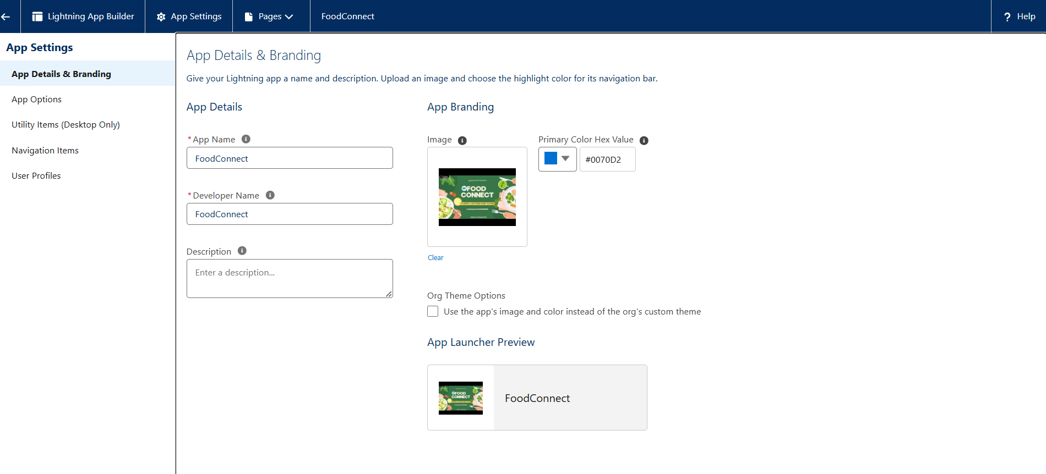

* To Add Navigation Items:
* Search for the item in the Home, Venue, Drop-Off Point, Task, Volunteer, Execution Details, Reports from the search bar and move it using the arrow button>Next.
* To Add User Profiles
* Search profiles System administrator in the search bar>click on the arrow button>save & finish.

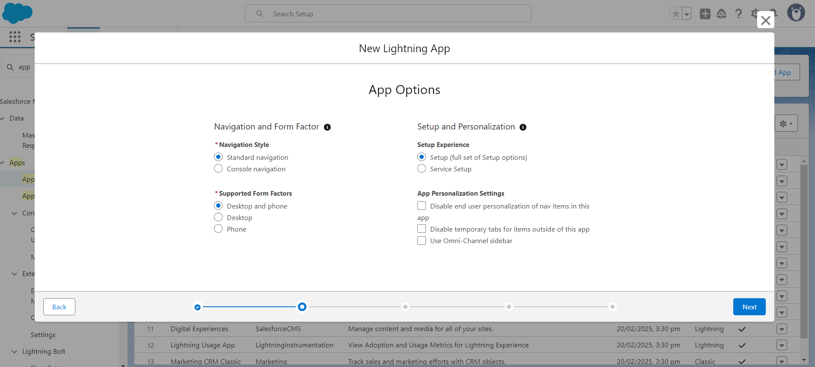

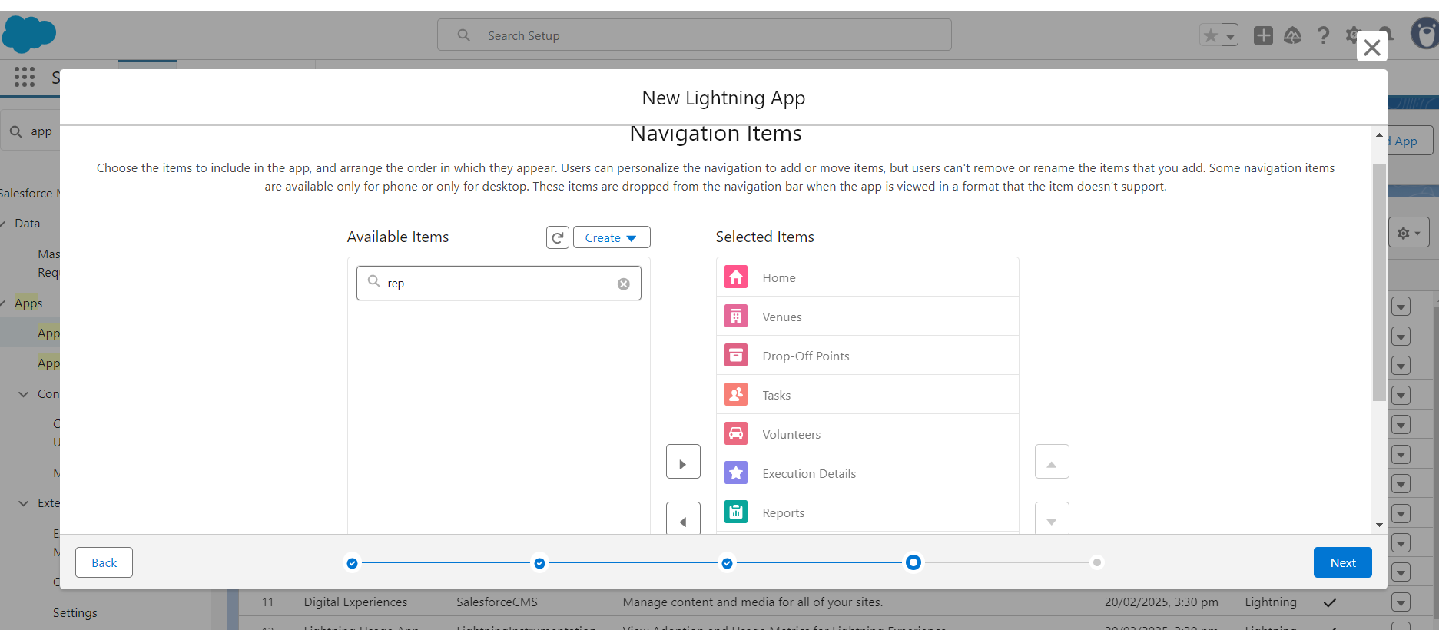

**Fields**

* A field in Salesforce is a column in an object that stores data.Fields are the basic unit of data storage in Salesforce.

### **Creation of Relationship fields in objects**

* Go to setup>click on Object Manager>type object name Volunteer in the search bar>click on the object.
* Now click on “Fields & Relationships”>New
* Select Master Detail relationship
* Select the related object “Drop-Off point” and click next.
* Field Name : Drop_Off_point
* Field label : Auto generated
* Next>Save.

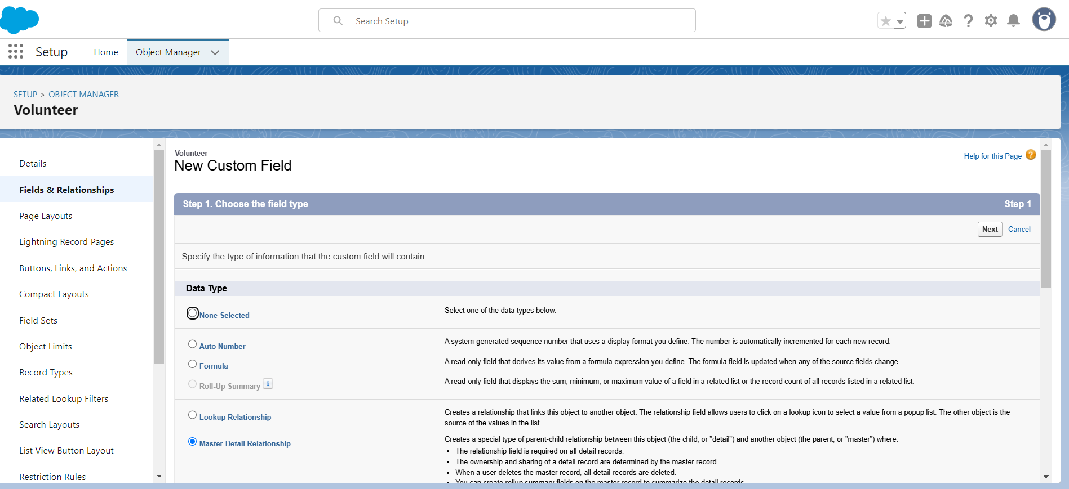

**Creation of fields for the Venue object**

* Go to setup>click on Object Manager>type object name **Venue** in search bar>click on the object.
* Now click on “Fields & Relationships”>New
* Select Data type as a “Email” and Click on Next
* Fill the Above as following:
* Field Label : Contact Email
* Field Name : Contact Email
* Click on required check box
* Click on Next>Next>Save and new.
* Similarly we have to create Contact Phone, Location, Venue Location, Venue Name

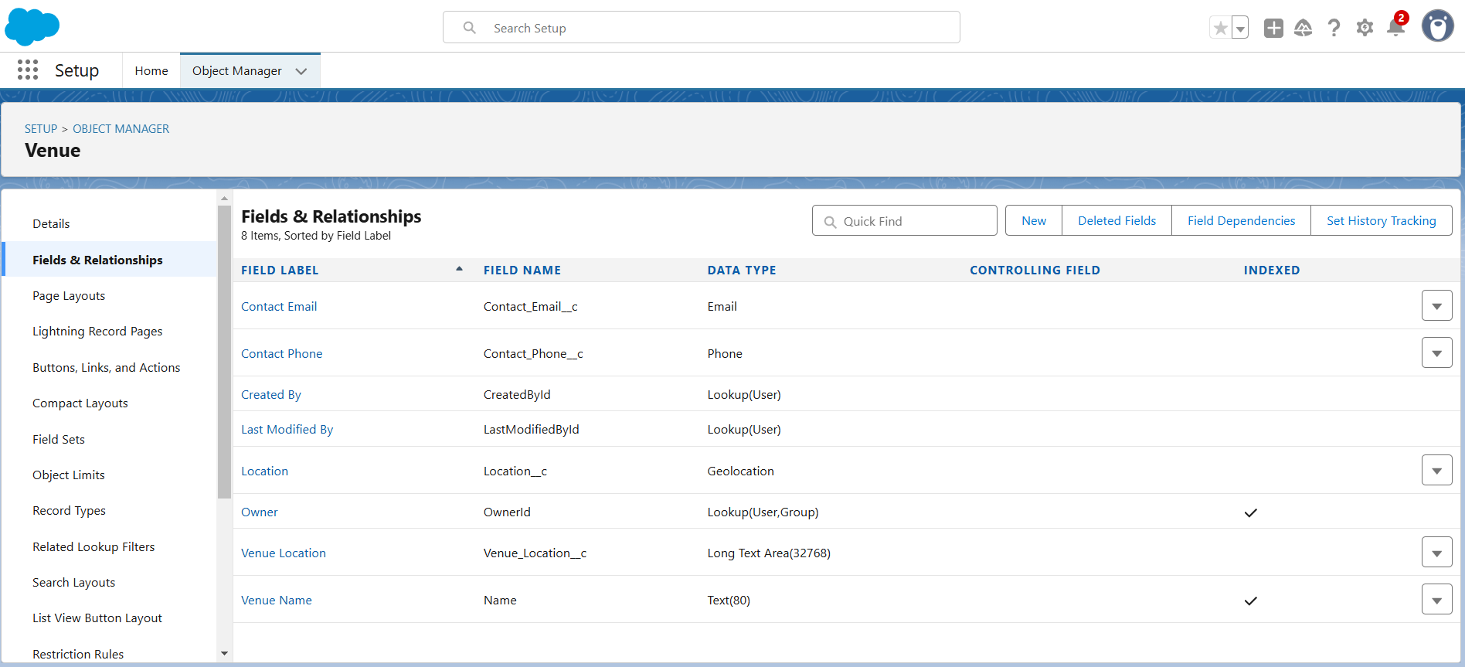

**Creation of fields for the Drop-Off point object**

* + Go to setup>click on Object Manager>type object name **Drop-Off point** in search bar>click on the object.
* Now click on “Fields & Relationships”>New
* Select Data type as a “Geolocation” and Click on Next
* Fill the Above as following:
* Field Label : Location 2
* Field Name : Location 2
* Description : Enter the Geolocation of the Drop off Point
* Geolocation Options : select Decimal
* Decimal Places : 4
* Click on Next>Save and new.
* Similarly we have to create distance_calculation, State, Distance.

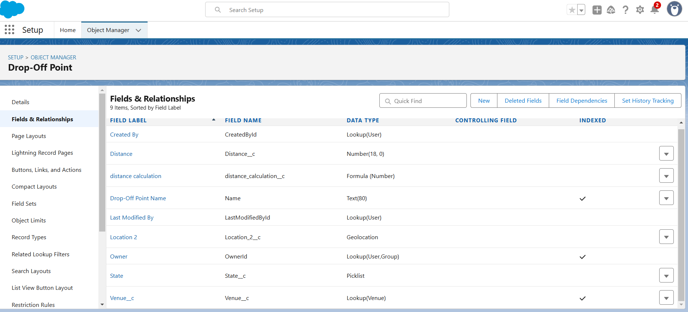

* **Creation of fields for the Task object**
  + Go to setup>click on Object Manager>type object name **Task** in search bar>click on the object.
* Now click on “Fields & Relationships”>New
* Select Data type as a “Auto Number” and Click on Next
* Fill the Above as following:
* Field Label : Task ID
* Display Format : TASK-{0}
* Starting Number : 1
* Field Name : gets auto generated
* Click on required check box
* Click on Next>Save and new.
* Similarly we have to create Date, Food Category,  Number of People Served, Name of the Person, Phone, Rating, Feedback

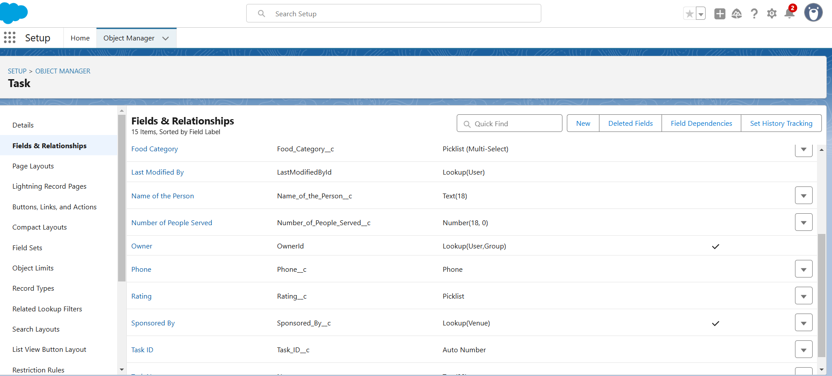

* **Creation of fields for the Volunteer object**
* Go to setup>click on Object Manager>type object name **Volunteer** in search bar>click on the object.
* Now click on “Fields & Relationships”>New
* Select Data type as a “Auto Number” and Click on Next
* Fill the Above as following:
* Field Label : Volunteer ID
* Field Name : gets auto generated
* Click on required check box
* Click on Next>Save and new.
* Similarly we have to create Gender, Available On, Age, Email, Contact Number, Address, Date of Birth.

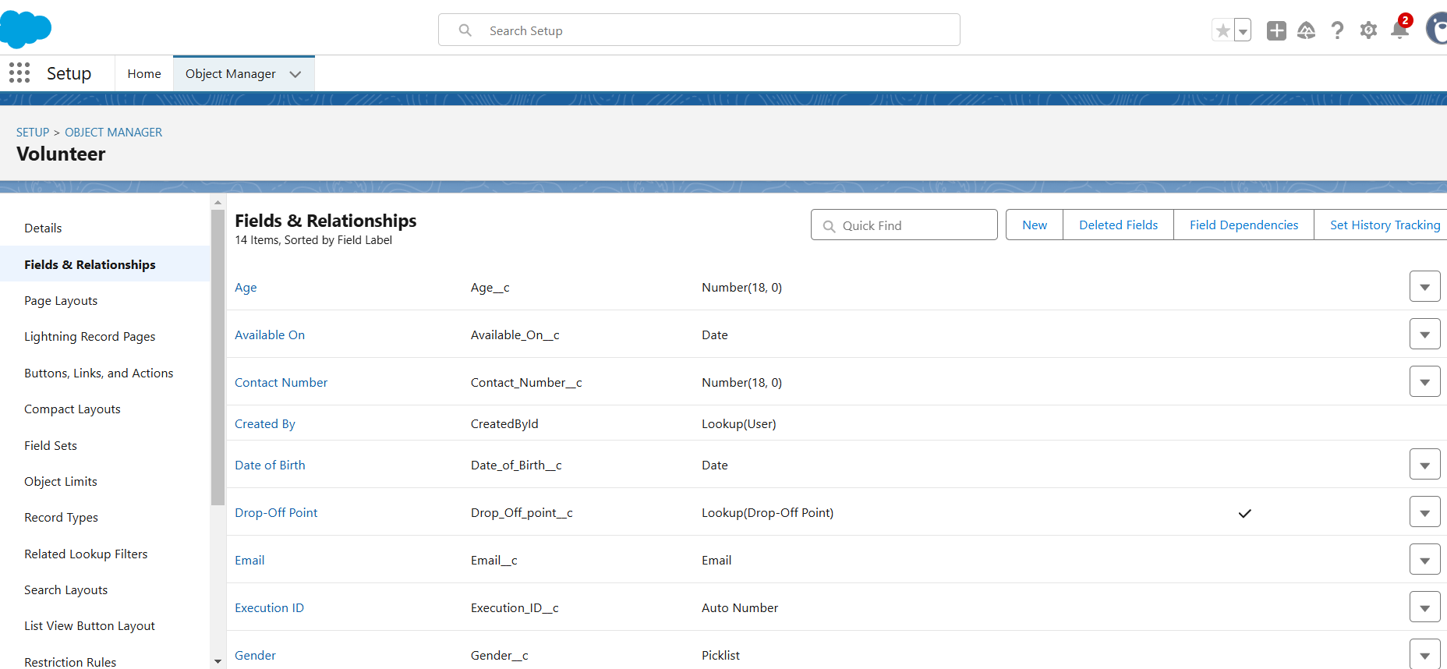

* **Creation of fields for the Execution Details object**
* Go to setup>click on Object Manager>type object name **Volunteer** in search bar>click on the object.
* Now click on “Fields & Relationships”>New
* Select Data type as a “Auto Number” and Click on Next
* Fill the Above as following:
* Field Label : Execution ID
* Field Name : gets auto generated
* Click on required check box
* Click on Next>Save and new.

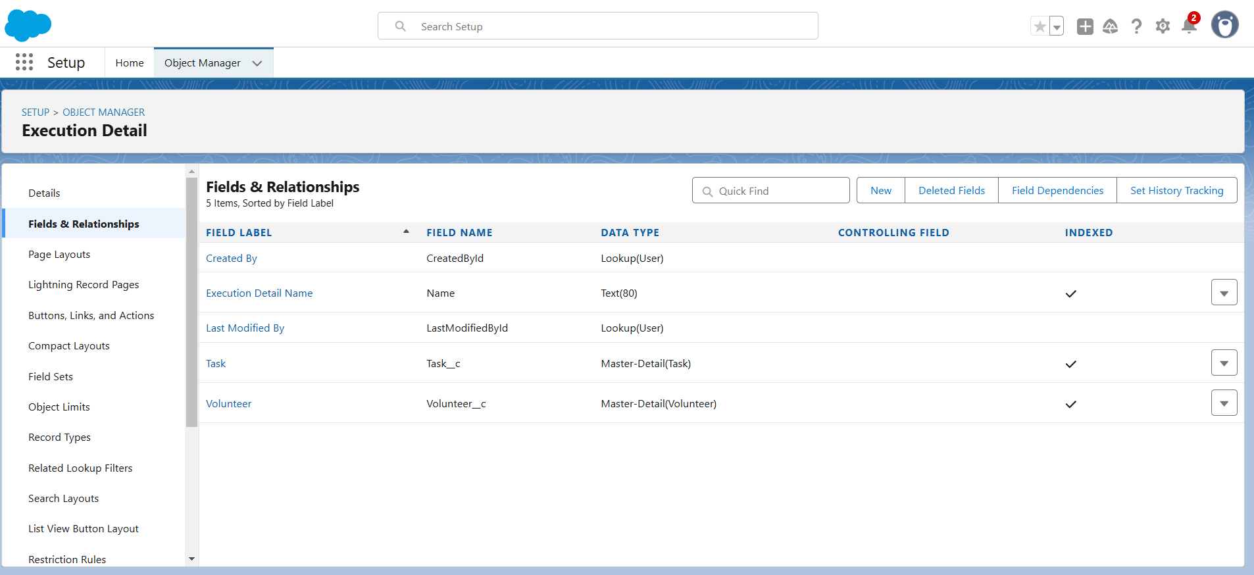

**FLOWS**

* Salesforce Flows are automated business processes that collect data and perform actions

### **Create Flow to create a record in Venue object**

* Go to setup>type Flow in quick find box>Click on the Flow and Select the New Flow.
* Select the Screen flow. Click on create.
* Click on the ‘+’ icon in between start and end, and click on screen element.
* Under the Screen Properties>Label : Venue Details> API Name : Venue_Details.
* Similarly we have to add Venue Name, Email, Phone, Venue Location, Latitude, longitude Components.
* Click on the ‘+’ icon in between Venue details and end, and click on create record element.
* Label : Create Venue Record> API Name : Create_Venue_Record.
* Set Field Values for the Venue : Click on ‘Add Field’ 5 times
* Field:Value=Contact_Email__c:{!Contact_Email.value}>Contact_Phone__c: {!Contact_Phone.value}> Name : {!Venue_Name}> Venue_Location__c :{!location}> Location__Latitude__s : {!latitude}> Location__Longitude__s : {!longitude}.
* Click on Save as> Flow Label : Venue Form> Flow API Name : Venue_Form.

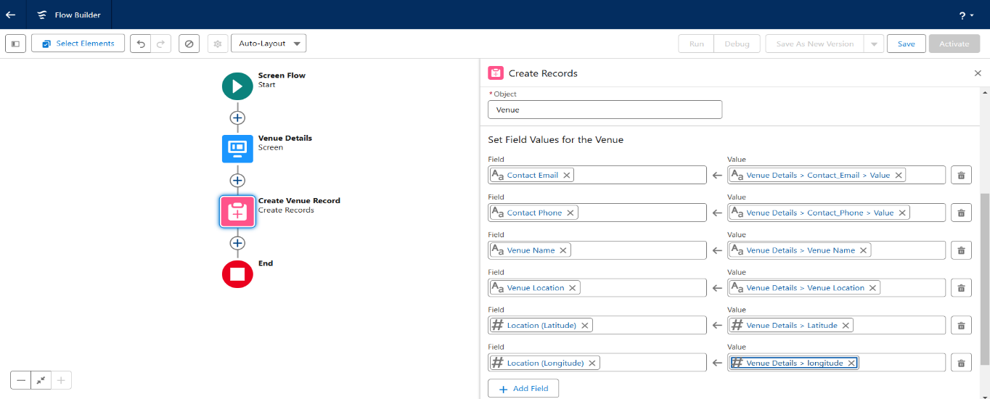

**Trigger**

* **Create a Trigger**
* Click on the gear icon>then click on Developer Console
* File menu in the toolbar, and click on new>Trigger
* Enter Trigger Name as DropOffTrigger> sObject: Drop-Off Point>Click on Submit.

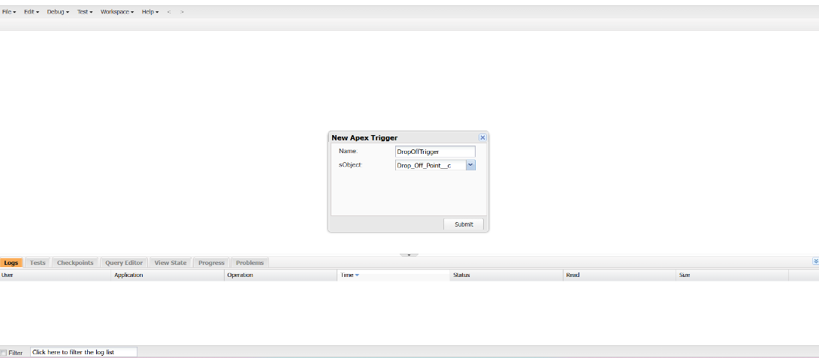

* **Trigger Code**

trigger DropOffTrigger on Drop_Off_point__c (before insert) {

    for(Drop_Off_point__c Drop : Trigger.new){

        Drop.Distance__c = Drop.distance_calculation__c;

    }

}

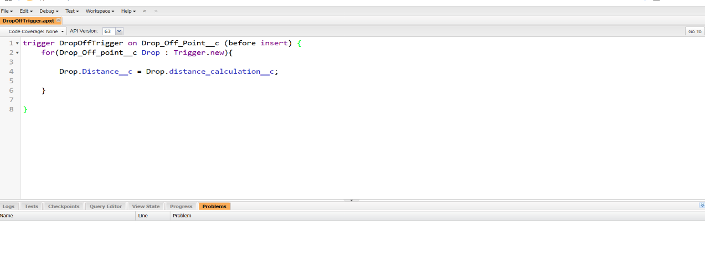

**Profiles**

* Go to setup page>type Profiles in Quick Find bar>click on **Profiles**>click on ‘S’
* Click on Clone beside Standard Platform User.
* Under Clone Profile:
* Profile Name : NGOs Profile
* Then click on Save

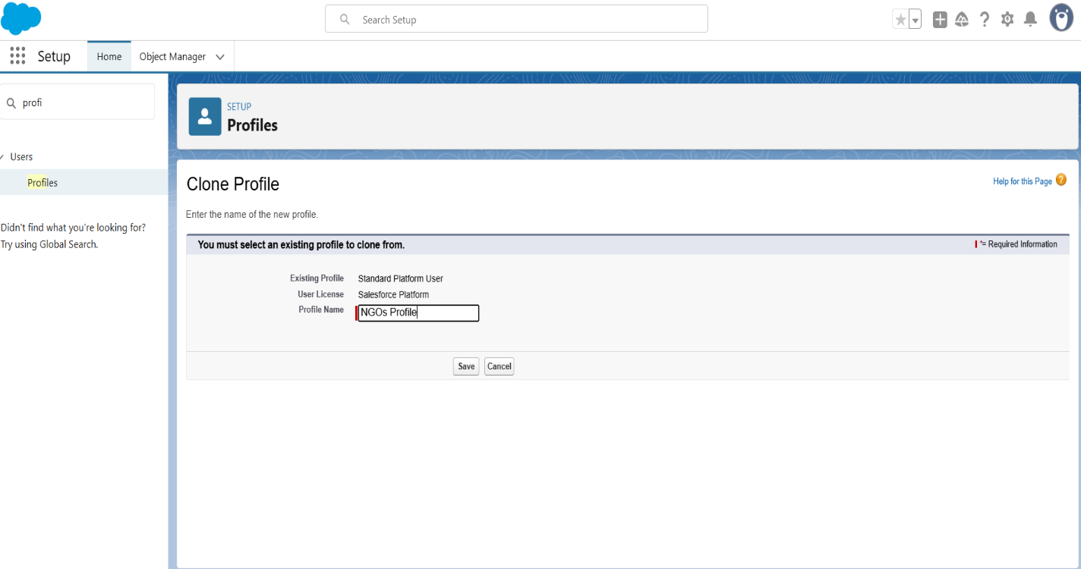

**Creation of Users**

* We consider as NGO’S

### **Creation of User1**

* Go to setup page>type users in Quick Find bar>click on users>New user
* First Name : Annamrita Foundation> Last Name : Annamrita_Foundation> Alias : aanna> Email : Give Your Email> Username : annamritafoundation@25.com> Nickname : Auto Populated> User License : Salesforce Platform> Profile : NGOs Profile> Active : Check
* Click on Save.

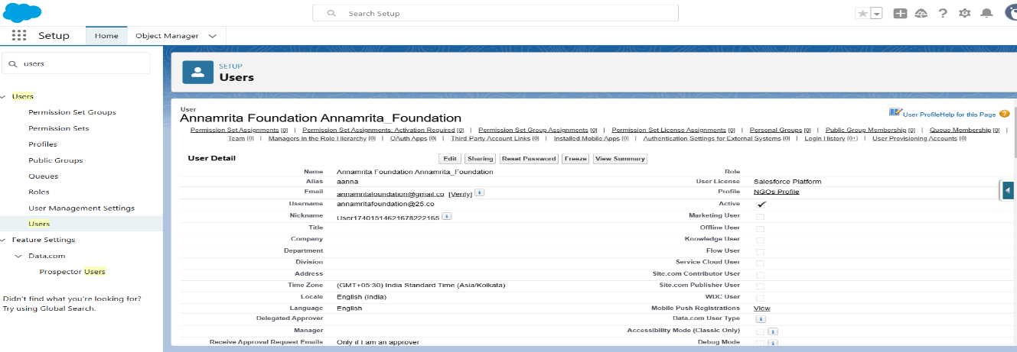

* **Creation of User2, User3**
* Similarly we have to create User2 as Uday Foundation and User3 as Sevadeep Foundation.

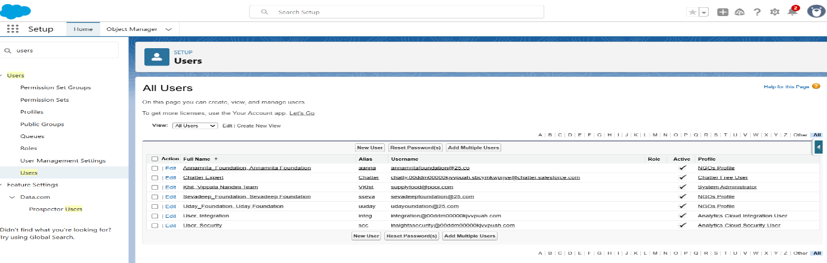

**Public Groups**

* **Creation of Public Group 1**
* Go to setup page>type Public Groups in Quick Find bar>click on **Public Groups**>click on New
* Under Group Information:
* Label : Annamrita> Group Name : Annamrita> Grant Access Using Hierarchies : Check
* In Search, Select Users.
* In Selected Members Add Annamrita Foundation and System Administrator.

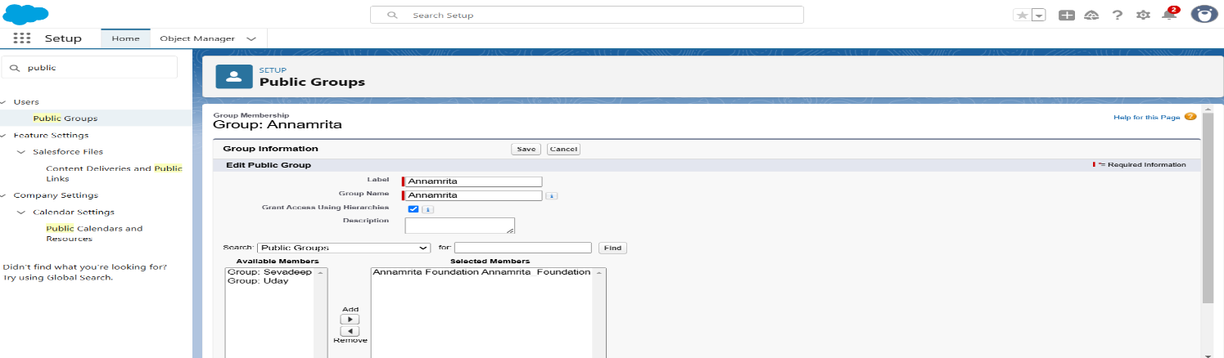

* **Creation of Public Group 2**
* Similarly we have to create Public Group 2.

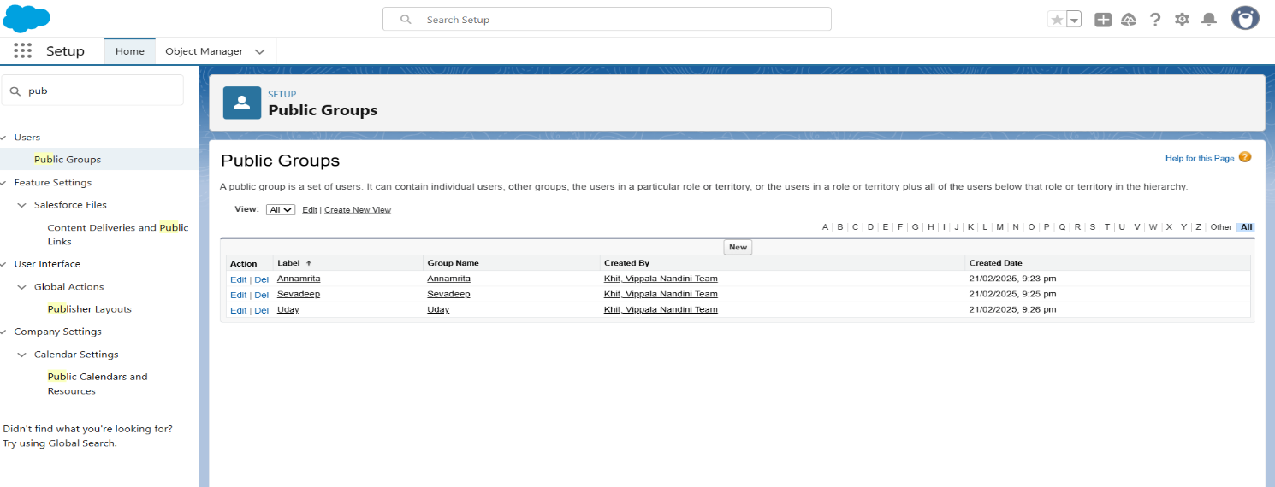

**Report Types**

* **Creation of Report Types**
* Go to setup page>type Report Types in Quick Find bar>click on **Report Types**>click on Continue>Click on New Custom Report Type**.**
* Primary Object : Select Venues>Report Type Label : Venue with DropOff with Volunteer> Report Type Name : Venue_with_DropOff_with_Volunteer> Description : Venue with DropOff with Volunteer> Store in Category : Select Other Reports> Deployment Status : Deployed> Click on Next> Near Click to relate another Object Select Drop-Off Points> And also select "A" records may or may not have related "B" records> Now again Near Click to relate another Object Select Volunteers
* Now click on Save.

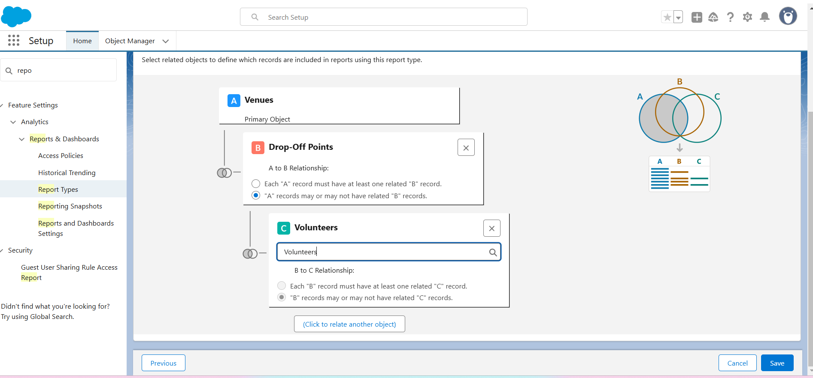

**Reports**

* **Creation of Report on Venue with DropOff with Volunteer**
* Go to the app **FoodConnect**>click on the **reports tab**>Click on New Folder.
* Folder Label : Custom Reports>Folder Unique Name : CustomReports>Open Custom Reports and click on New Report
* Select Report Type : Venue with DropOff with Volunteer>Then click on Start Report.
* In GROUP ROWS : Add Volunteer Name
* In Columns : Add Venue Name, Drop-Off point Name, Distance
* Now click on Save & Run.
* Give Label as>Report Name : venue and Drop Off point>Report Unique Name : Auto Populated >Click on Select Folder and select Custom Report
* click on Save.

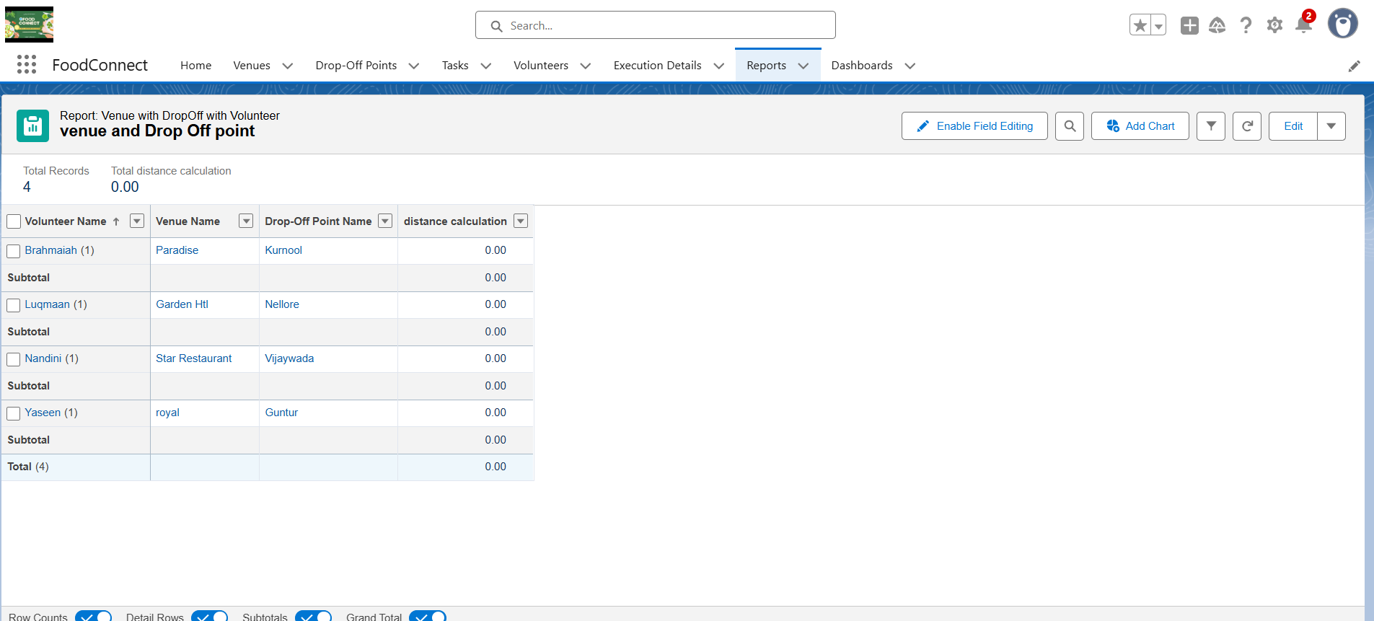

* **Creation of Report on Volunteers with Execution Details and Tasks**
* Go to the app FoodConnect >click on the **reports tab**> Click on Custom Reports Folder and click on New Report
* Select Report Type : Volunteers with Execution Details and Tasks> Start report
* In GROUP ROWS : Volunteer ID
* In Columns : Add Volunteer : Volunteer Name, Task : Task Name, Execution Detail : Execution Detail Name, Volunteer: Owner Name, Task: Date, Task : Rating
* Now click on Save & Run
* Give Label as> Report Name : Volunteer Task> Report Unique Name : Auto Populated> Click on Select Folder and select Custom Report
* Click on Save.

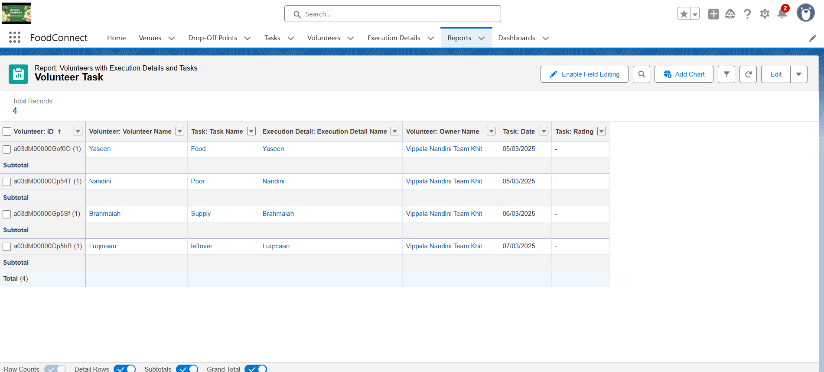

**Dashboards**

* **Adding Venue, Drop_of_Point, Volunteer Reports and Picture on Dashboard**
  + Go to the app **FoodConnect**>click on the **Dashboards>**New Folder as Label Name: Cutom Dashboards>Unique Name: Auto Populated>New Dashboard click on Widget>Select required Repord>Add required Component display and theme
  + Click on Save.
  + Similarly we can add picture in dashboards.

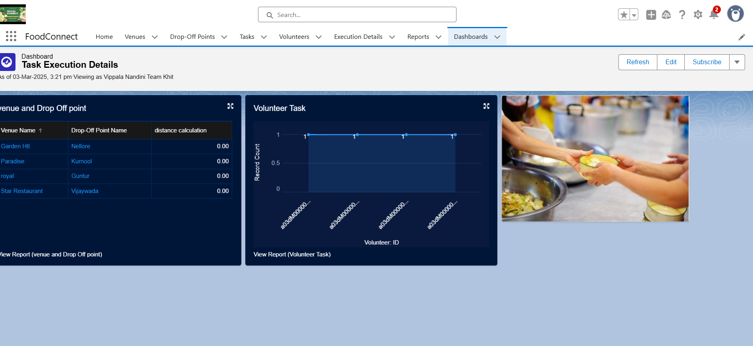

**Sharing Rules**

* **Creation of sharing rules**
* Go to setup>type Sharing Settings in quick find box>Click on the Sharing Settings
* Select Drop of Point Name it as Label: Rule1>Rule Name: Rule_1>Based on criteria we have to select Field: Operator: Value = Distance: less than: 15>Near share with as Public groups: Annamrita
* Click on save.
* Similarly we have to create Rule2 as Public group name Sevadeep and Rule3 as Public group name Uday.

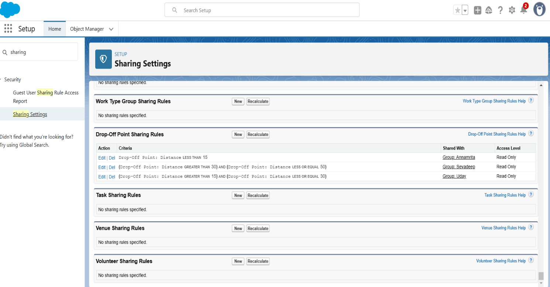

**Testing and Validation**

**Home Page**

* Edit Home Page as Label as **HOME** and drag the components flow and name as Venue Flow and Dashboards **.**
* Click Save and Activation
* Add FoodConnect app and then save.
* The Home Page which we need to Validate is Displayed.

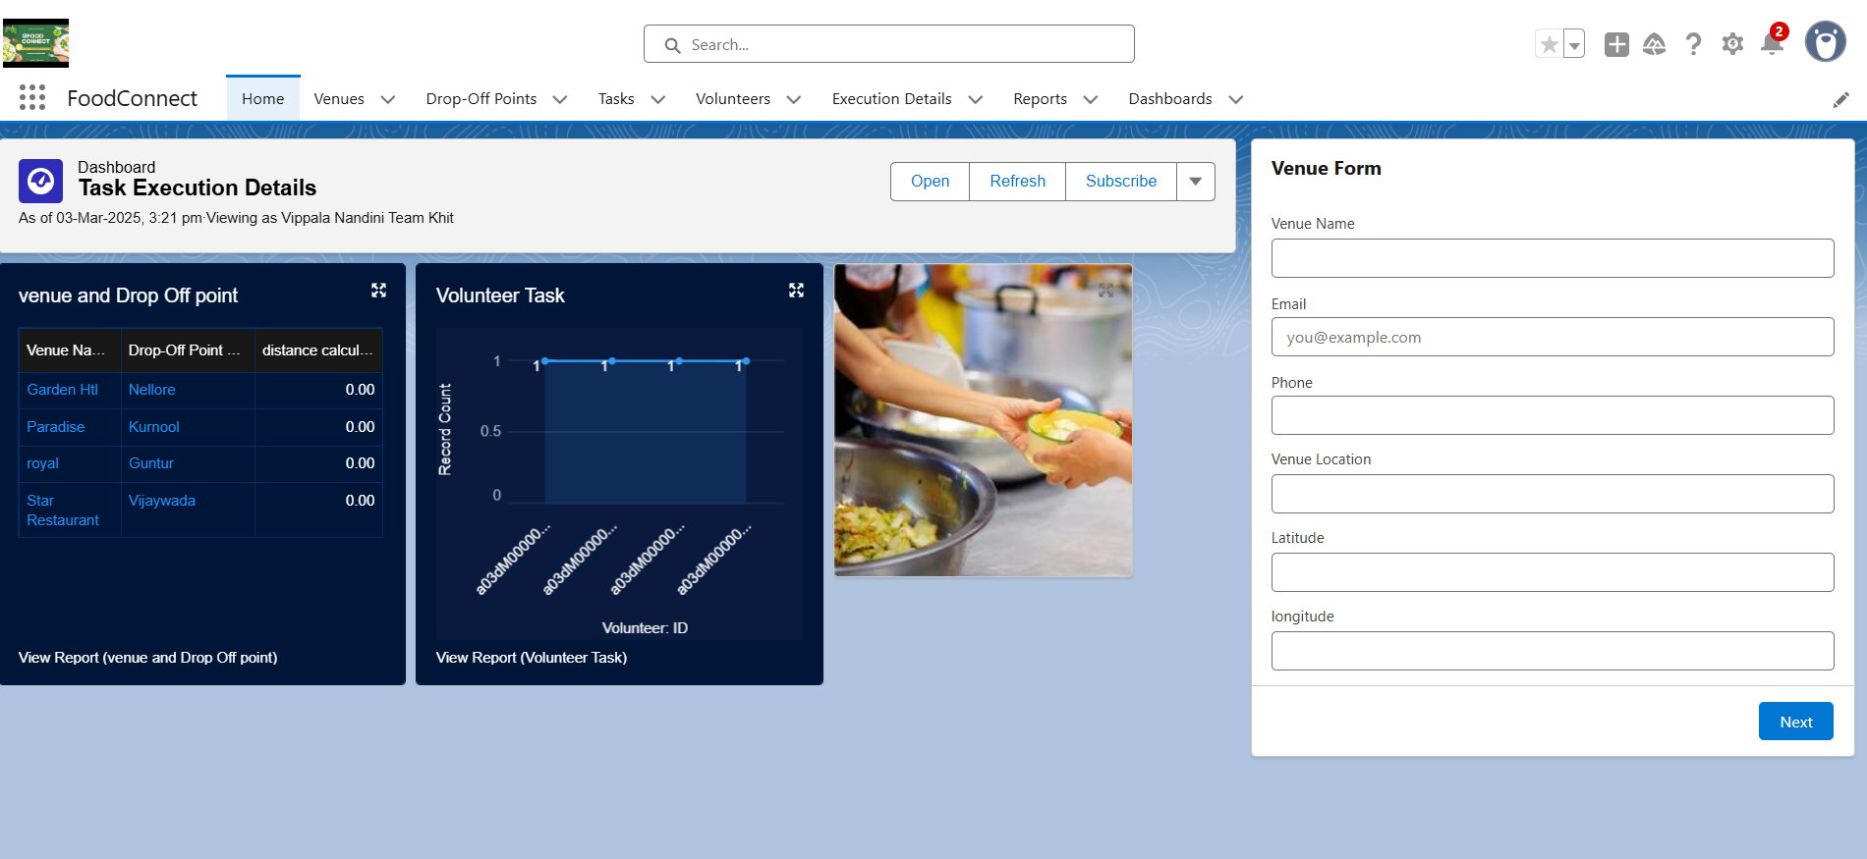

### **Conclusion** The "**To Supply Leftover Food to the Poor**" project has been a meaningful initiative aimed at reducing food waste while addressing hunger in our communities. By collaborating with restaurants, hotels, and event organizers, we have successfully collected surplus food and redistributed it to those in need.

### This project has not only provided nourishment to underprivileged individuals but has also promoted social responsibility and environmental sustainability. Through effective planning, coordination, and awareness campaigns, we have encouraged people to contribute to this cause, fostering a culture of compassion and waste reduction.

### Moving forward, we aim to expand the reach of this initiative by involving more stakeholders and improving logistics for efficient food distribution. With continued community support and dedication, this project has the potential to make a long-term impact in alleviating hunger and ensuring that no edible food goes to waste.